Project Overview - Parvata

0. Entertainment/Art - Bookbinding

1. High level description of the software. (100 words max)

2. Businesses needs to reformat and organize digital pages for printing in a foldable book layout, as to be used in bookbinding. Varying paper, page, and signature sizes will be used. Documents will generally be in, or easily converted to, PDF format. Output layout must be able to be acutely defined by the user, based on the printing and folding techniques to be used.

The vision of Parvata is create a free imposing software with an open source license, for hobbyist bookbinding communities to corporations. This system will be free from watermarks, ads, and other intrusive features. Parvata is designed to be lightweight and accessible to all.

* + User wants to impose a book to and from PDF format. Layout and file locations must be specified by the user.
* User wants to edit layout files. User must specify input/output files and the layout.

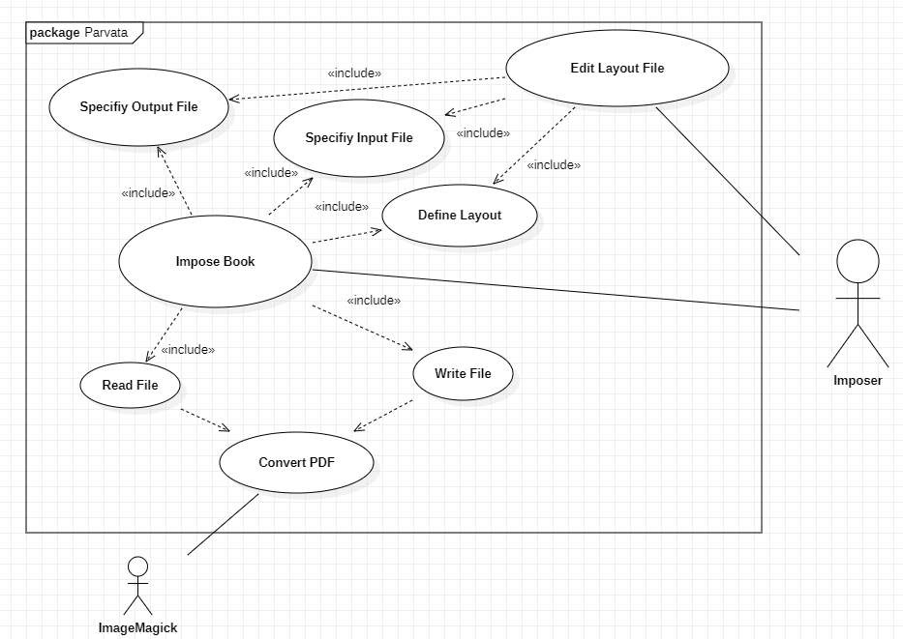

3. Hundreds to thousands of dollars saved over the course of a year, as compared to various alternative software. Increased accessibility to hobbyist communities.

4. Estimated Cost: 4 part time developers, 2 months of work with additional features and support thereafter.